**QS1:** STAR LAWS (Shedding Light on Astronomy) Episode I:  **What Causes Day and Night?**Name: _________________________________________________

1. What is astronomy? _________________________________________________________________________  
   ____________________________________________________________________________________________________________________________________________________________________________________
2. The sun rises every day in the _________________ sky and sets in the evening in the ______________ sky.
3. Explain why we have day and night. Use text and a diagram.

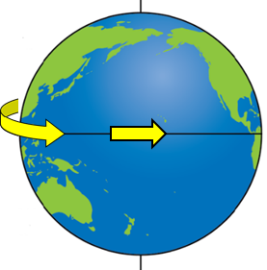__________________________________________________  
__________________________________________________  
__________________________________________________  
__________________________________________________  
__________________________________________________  
__________________________________________________  
__________________________________________________  
__________________________________________________  
__________________________________________________

1. Label the diagram on the right.
2. 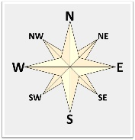The north pole
3. The northern hemisphere
4. The equator
5. The southern hemisphere
6. The south pole
7. The Earth spins from _____________ to ______________.
8. Go to Google Maps ([www.google.com/maps](http://www.google.com/maps)) and find either your house or the classroom that you are in. Draw a simple labelled map of your house (or your classroom building) and the street in the space provided.
9. 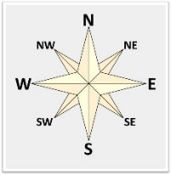When you leave your house to go to school in the morning (or when you leave school to go home), in which approximate direction do you travel along your street? _____________________________________
10. The sun rises in the general direction of ________________. In the early morning, the sun is relatively __________ (low or high) in the sky. Shadows are relatively ______________ (long or short) and point roughly towards the ________________.
11. Which rooms of your house (or school building) receives early morning sunlight? ______________________________________________________
12. The time of day that the sun reaches its highest point in the sky is called ____________ ___________. At this time the sun is relatively __________ (low or high) in the sky and shadows are relatively __________ (long or short).
13. In the evening, the sun is relatively ________ (low or high) in the sky. Shadows are relatively ______________ (long or short) and point roughly towards the ________________. The sun sets in the general direction of _______________.
14. Which part of your house (or school building) receives evening sunlight? _________________________________________________________________________________________
15. Why are tennis courts (and cricket pitches) aligned north south? _____________________________________  
    ______________________________________________________________________________________________________________________________________________________________________________________________________________________________________________________________________________
16. Do a google maps search of your local area for tennis courts. Are there any courts that are not aligned north south (or close to north south)? ________________________________________________________________  
    __________________________________________________________________________________________

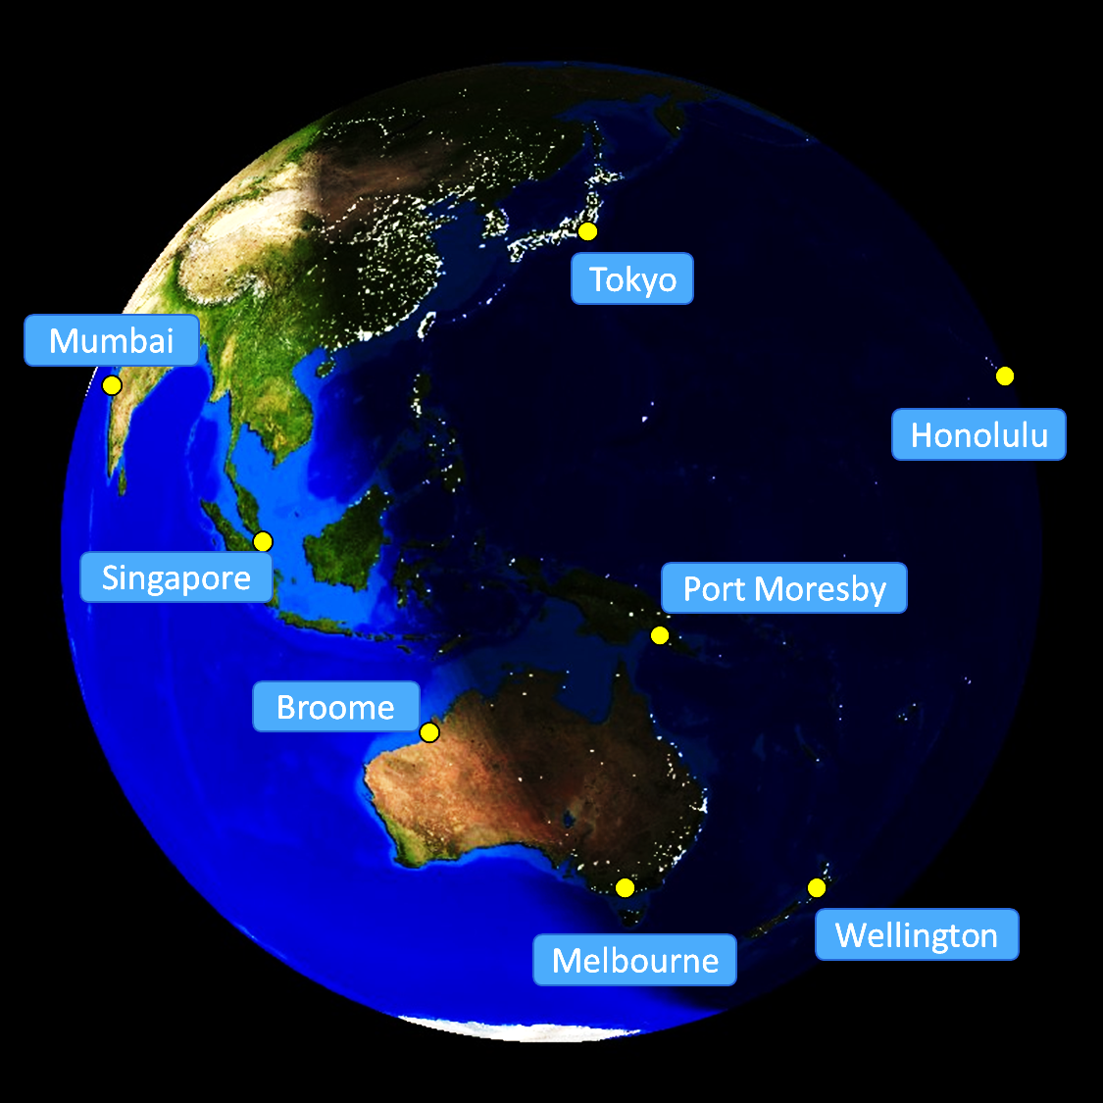

This image of the Earth was generated by the US government’s National Oceanic and Atmospheric Administration.

1. Which cities in the photo are experiencing daytime?

__________________________________________________________________________________________

1. In which city will the sun set first? ____________________________________ (You may wish to revisit Q4.)
2. In which city has the sun just set? ____________________________________
3. In which city is it close to midnight? ___________________________________
4. In which city has midday occurred most recently? ______________________________
5. Which city will experience sunrise first? ________________________________